**LITERATURE SURVEY ON SMART SOLUTIONS FOR RAILWAYS**

Information Technology has elaborated to an immense level and is being utilized in the field of transportation services.Roaming in Train is the most under-value form of long-distance travel. In addition, travelling by train is time preserving as the trains usually runs on time. Furthermore, many train journeys over long distance need reservations, but the short distance train journey requires an ordinary railway ticket. For Indian railways, to buy ordinary tickets, the traveler has to abide in long queue. Standing in queues which is a protracted, vexatious and inconvenient process as time demand is more. With respect to Mumbai Suburban Railway, one of the major problems faced by the 7 million people, who travel by local trains every day, is standing in the long queues for an average of 10-15 minutes to buy a ticket.

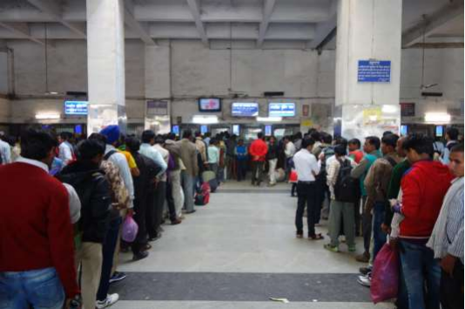

Sometimes many citizens facing problems to reach the railway station on time due to one or more reasons. Sometime ticket issuing officer generates a ticket only if we provide change money. It is risky to carry money for purchasing tickets. In addition, a citizen who wants to issue season ticket, has to abide in the queues.

To overcome all these offline railway reservation issues, it is highly recommended to go with online ticket booking system. Because there is no serious drawback in online reservation system. It is very convenient for travelers as they can book reserved ticket from anywhere at any time as per their convenience. No cash is required, payment is made through net banking/cards/UPI etc. Refund also gets credited to the bank account within a week.

**WORKING:**

The reservation system should works under the following process:

* If a passenger/user wants to reserve ticket(s), first he/she has to register by giving their entire details such as their name, full address, sex, age, mobile number, email id.
* After successful registration, user has to login with valid credentials as provided.
* Then the user can be able to search the availability of train on particular date to have their journey.
* If the user has to boom ticket, they have to provide type of reservation such as General, Tier 1, 2 or AC type.
* Then they have to enter total number of tickets they require and their details except the current user.
* User will be provided with ticket number along with journey details.
* Apart from this, user can able to print the tickets, make cancellations, check their current location during travel.

**EXISTING SYSTEMS:**

Facility for purchasing unreserved tickets through mobile phone is available at DELHI, Mumbai, Chennai, Kolkata and Secunderabad railway stations.

Android Suburban Railway(ASR) ticketing is to purchase the suburban tickets by ‘M-ticket’. ASR ticket can be purchased with smart phone app through which travelers can travel with railway tickets in smart phone as QR (Quick Response) code. ASR utilizes smart phone’s GPS (Global Positioning System) to authenticate and obliterate generated ticket itself following a definite time of period once traveler accomplish the journey. In addition, the railway ticket checker is supplied with a checker application to verify the traveler’s ticket with the ticket number and generated QR code.

A Wi-Fi router is set up at ticket counter. In addition, router does not require internet connection. Furthermore, Wi-Fi router is connected to the railway server. When travelling with an android application in smart phone arrives near the region of ticket issuing counter area, traveller initially connect with Wi-Fi router. Later traveller will prompt with source railway station name automatically. Subsequently traveller has to enter his credential for authentication of traveler. If traveller enters correct credential then application allows travelers to select destination based on route that has to be travelled by traveler. Further traveller has to enter number of tickets required. Traveller information will be verified at a railway server via Wi-Fi router. If information entered by travelers are valid then based on number of ticket required payment will be done and later travelers receive message which is identical to the railway ordinary ticket.

Traveller who want to buy an online ticket has to download application for smart phone. Then the traveler will prompt to insert the train information like source and destination station, number of tickets required to generate including the category of passenger like an adult or child, and class of ordinary ticket like first or second class. Final cost of ticket/s will be calculated based on information inserted and train information stored in database. After successful deduction of payment via diverse payment methods, the ticket is generated with information similar to the paper-based tickets.

The Android Ticketing of Railways (ATR) is a online railway ticket system where the ticket can be bought easily from any place in the internet enable smart phone. The ticket will be generated in a smart phone in the form of Quick Response(QR) Code. In addition, the ticket checker is facilitate with a QR code scanner to check traveller tickets based on information store at database.

**REFERENCES:**

1. [www.projectsgeek.com](http://www.projectsgeek.com)
2. [www.researchgate.net](http://www.researchgate.net)
3. [www.geeksforgeeks.org](http://www.geeksforgeeks.org)
4. S. Shaikh, G. Shinde, M. Potghan, T. Shaikh, and R. Suryawanshi, “Urban Railway Ticketing Application,” vol. 4, no. 1, pp. 130–132, 2014.
5. International Journal of Engineering Development and Research ([www.ijedr.org](http://www.ijedr.org))